Lab 7 Report

Objectives
Follow the instructions and complete the listed tasks.

2. Environment Setup
Operating System: macOS Sequoia 15.7.1 (ARM64)
Platform: Minikube running on Docker Desktop
Kubernetes Version: v1.29.3
Istio Version: 1.28.0

3. Getting Started
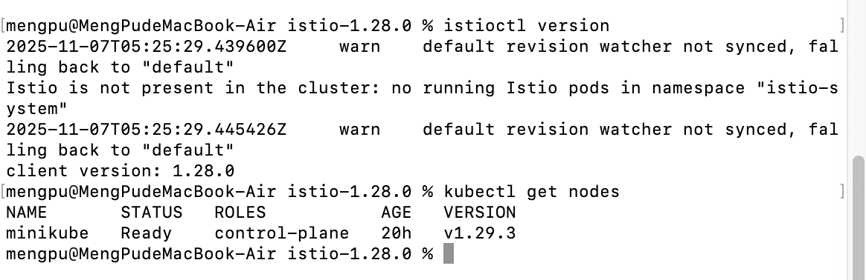
Figure : Verifying Istio CLI and Kubernetes node readiness.

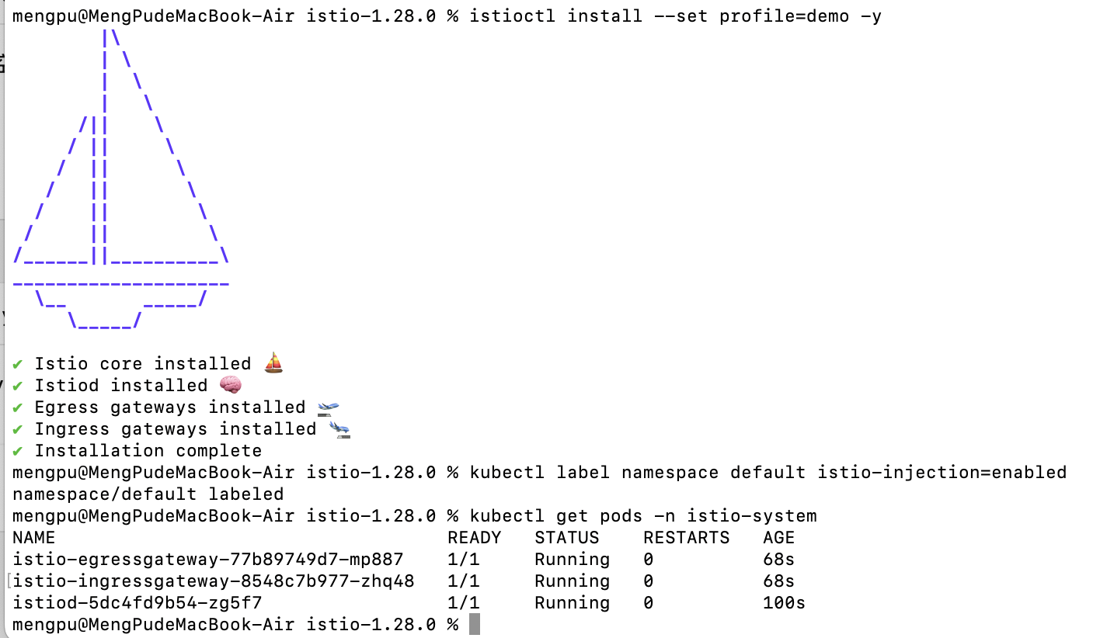
Figure : Install istio

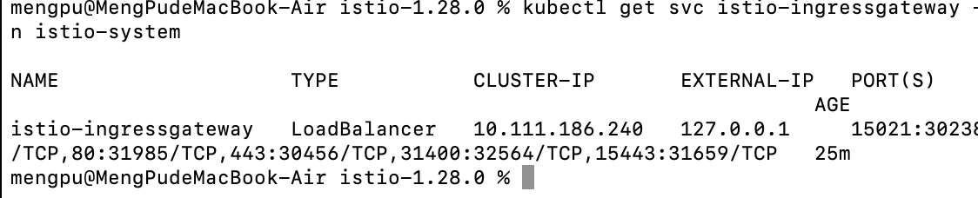
Figure : Checking Istio Ingress Gateway service and exposed ports.

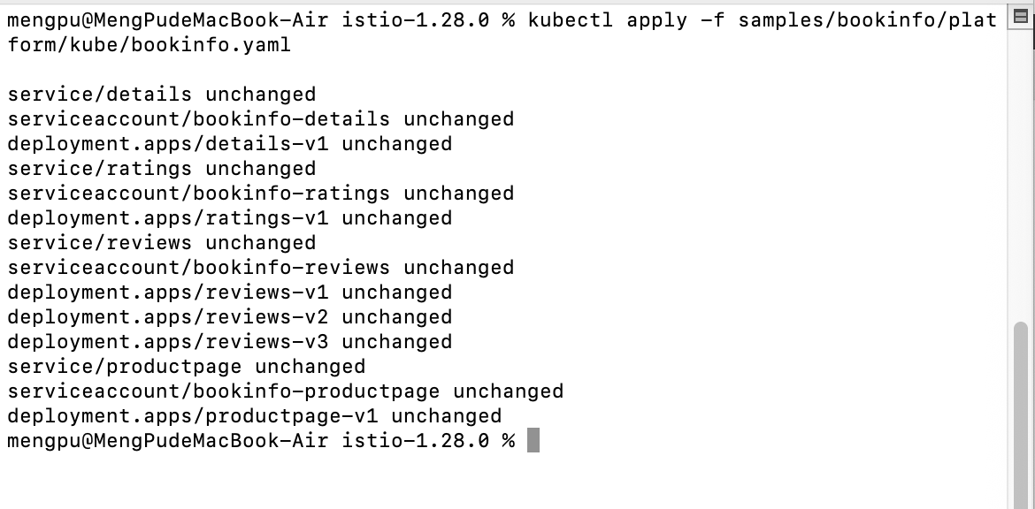
Figure : Deploying the Bookinfo sample application on Kubernetes.

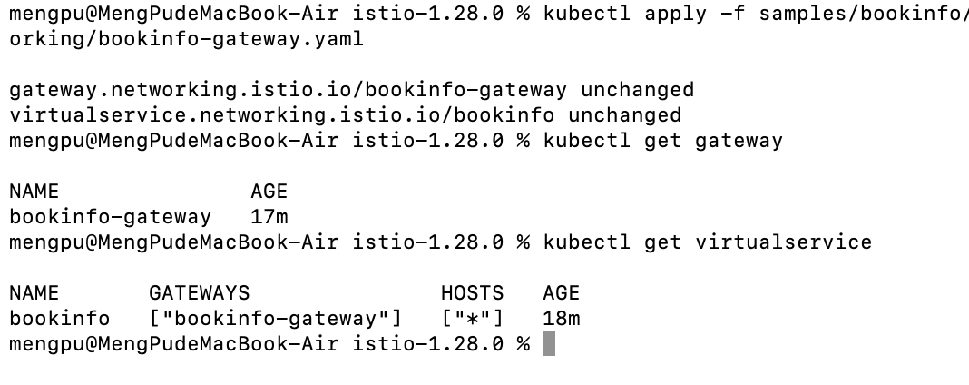
Figure : Creating Istio Gateway and VirtualService for Bookinfo routing.
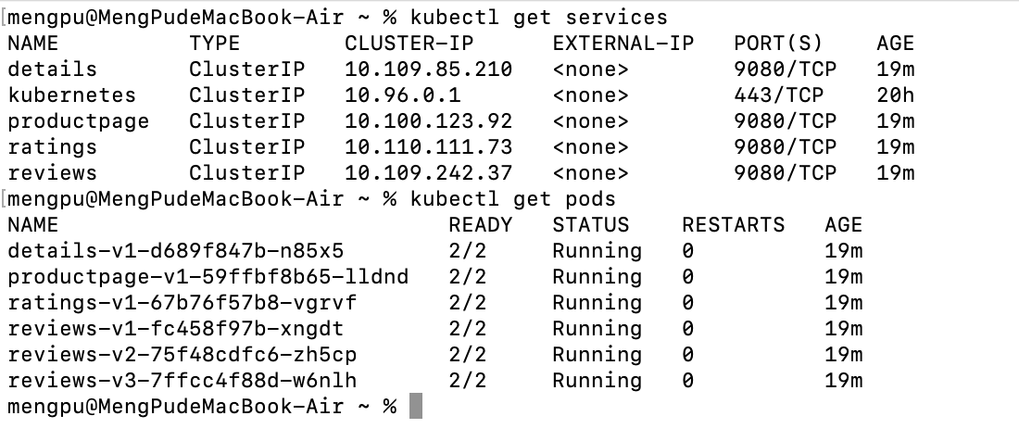
Figure : Verifying all Bookinfo services and pods are running correctly.

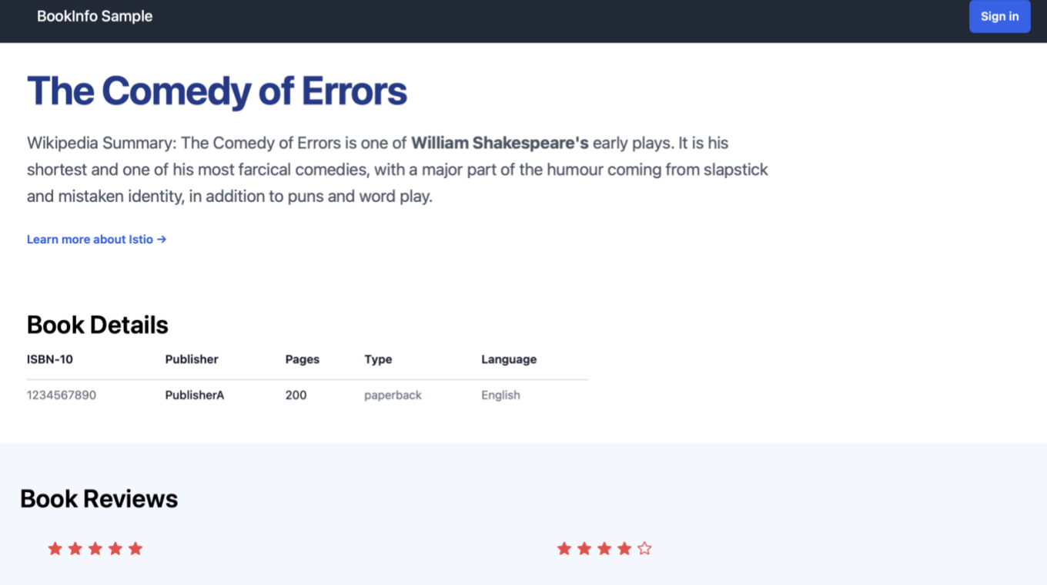
Figure : Accessing Bookinfo application webpage (initial version, no reviews shown).
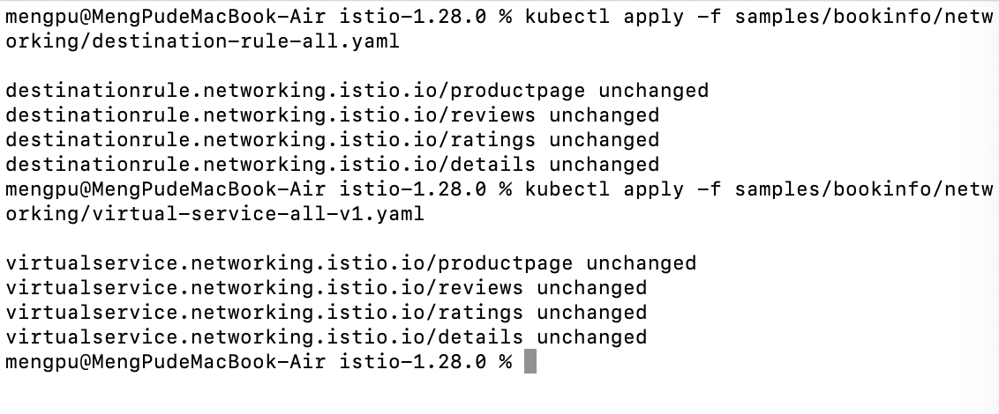
Figure : Applying DestinationRule and VirtualService configurations.

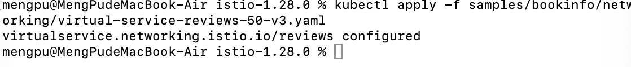
Figure : Applying version v3 routing rule for reviews service.
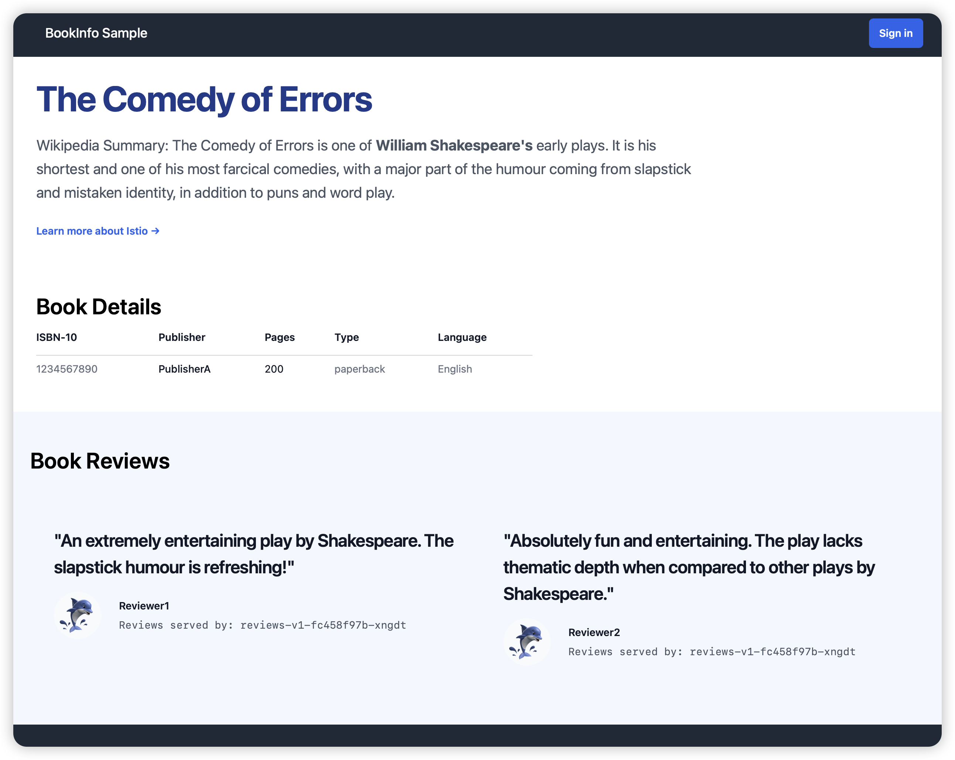
Figure : Bookinfo webpage showing mixed review routing behavior.

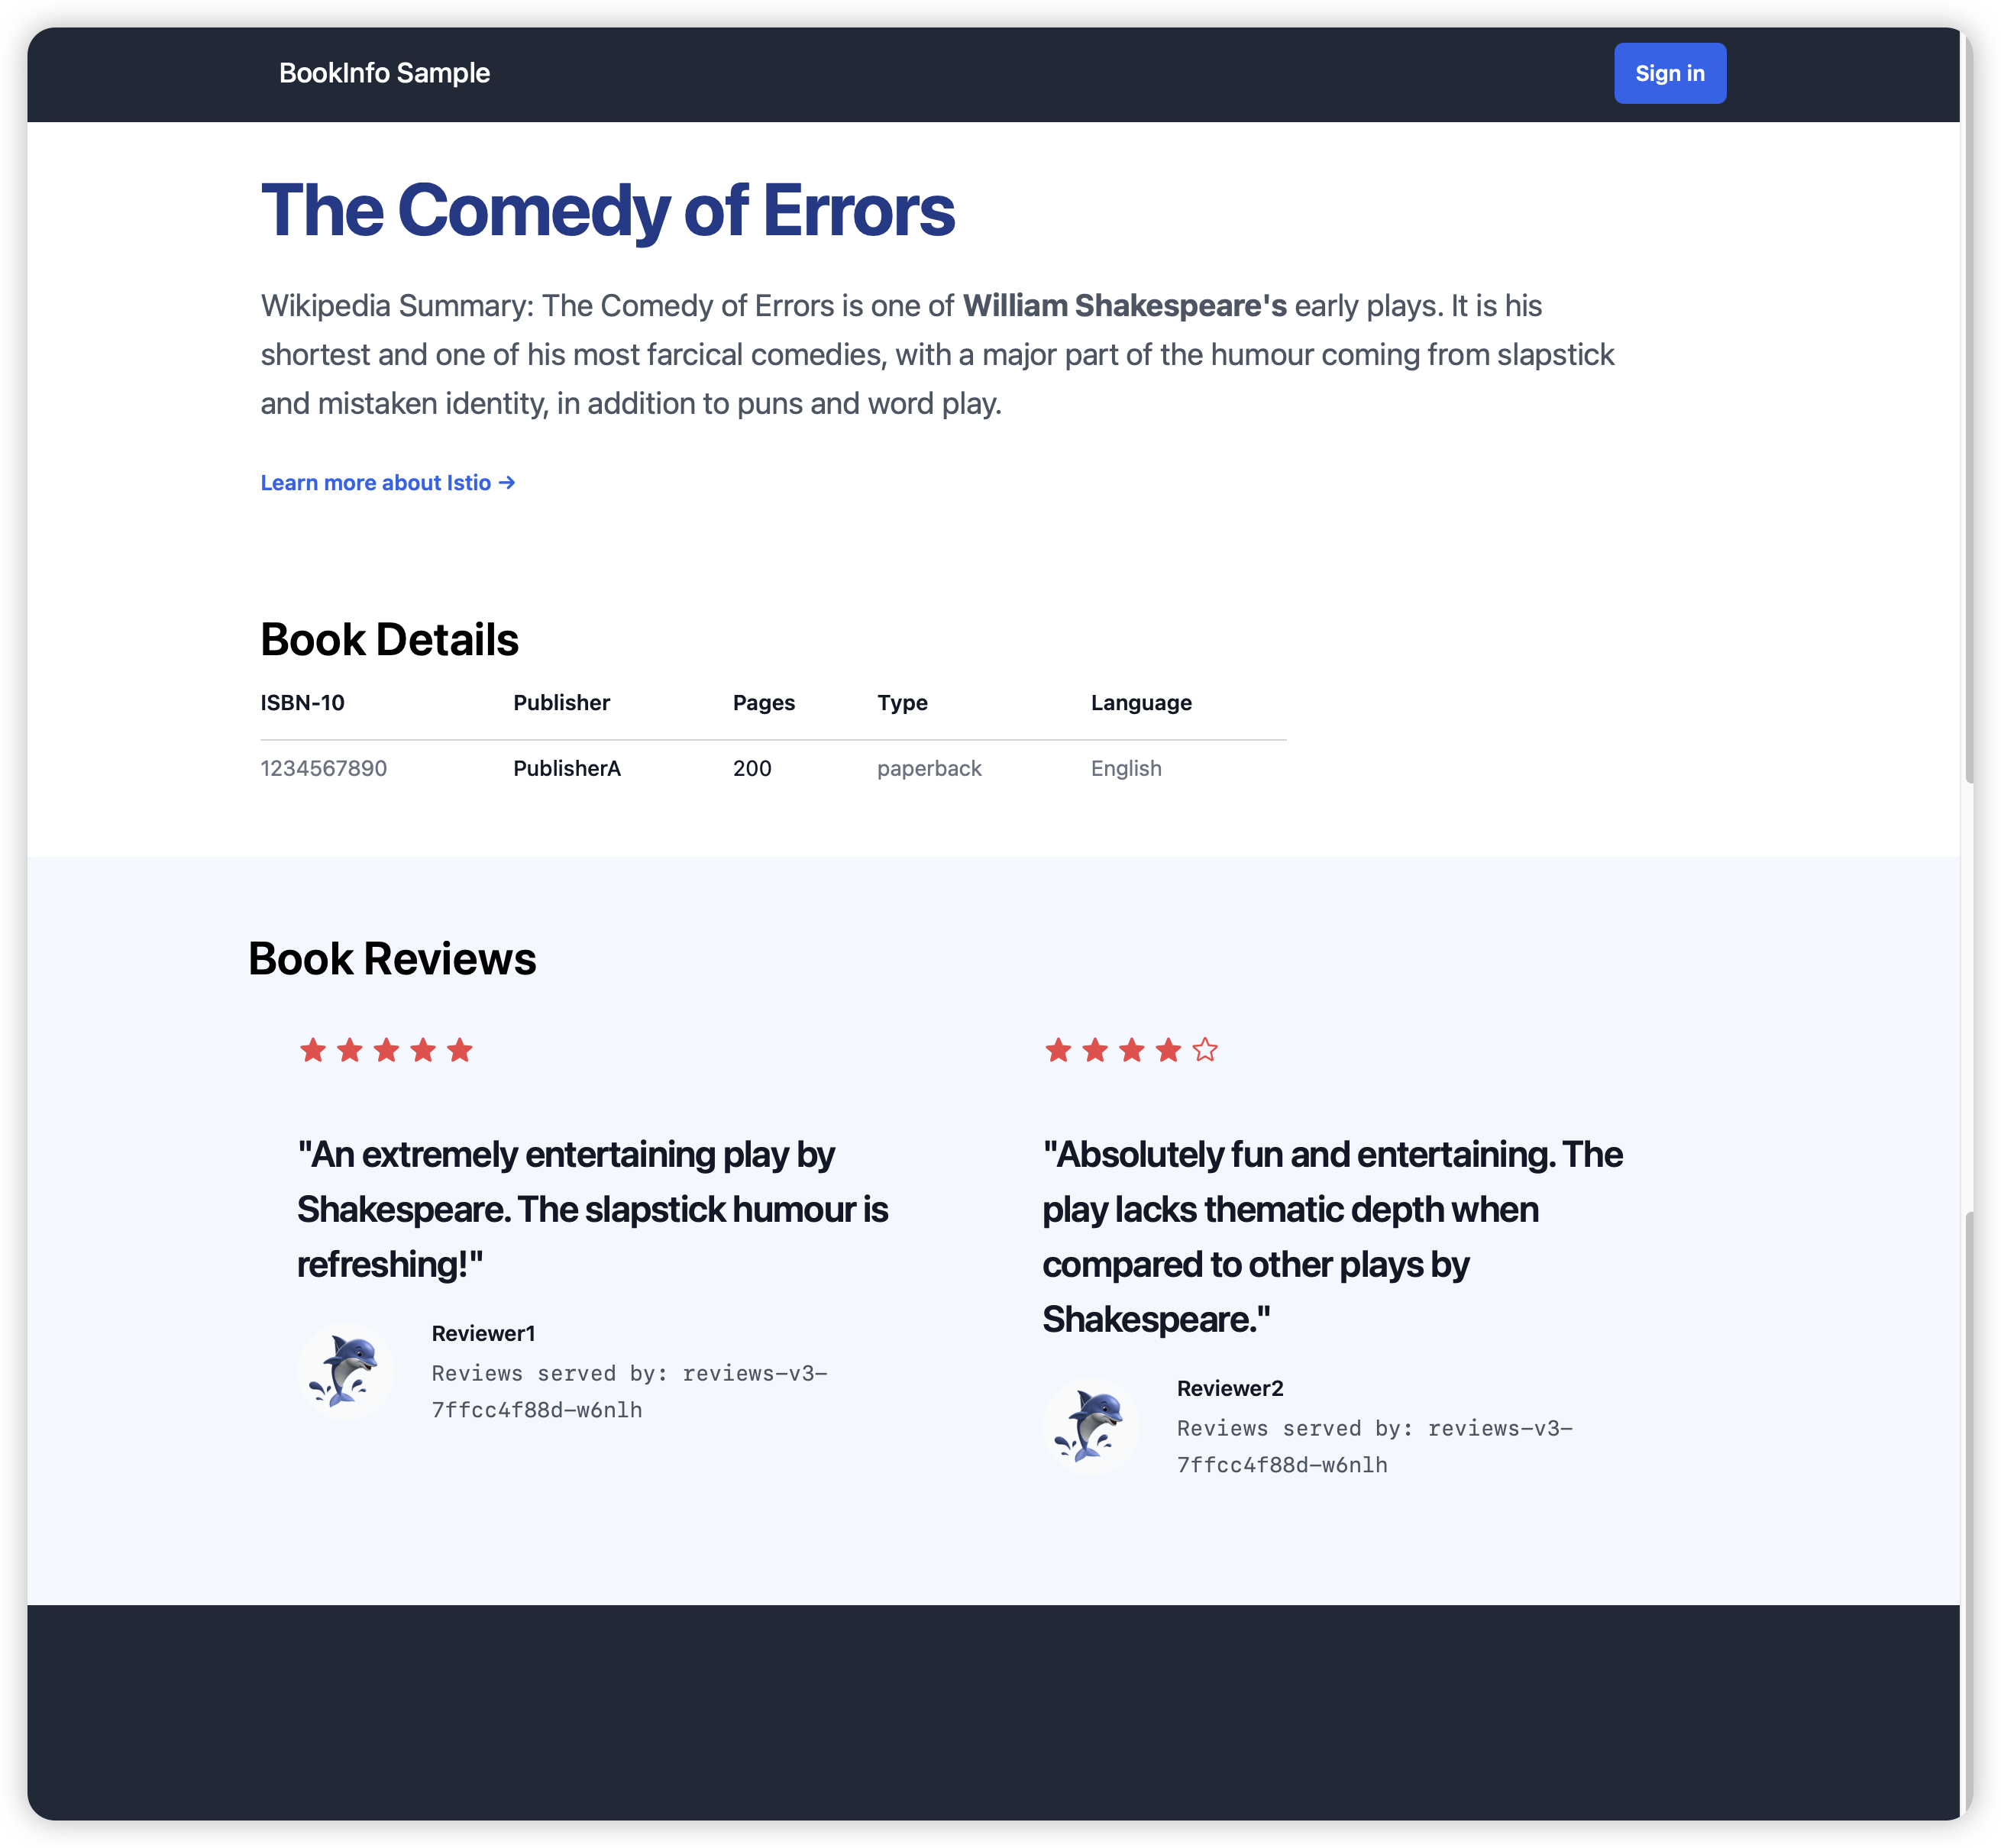
Figure : Bookinfo webpage showing v3 routing with star ratings.
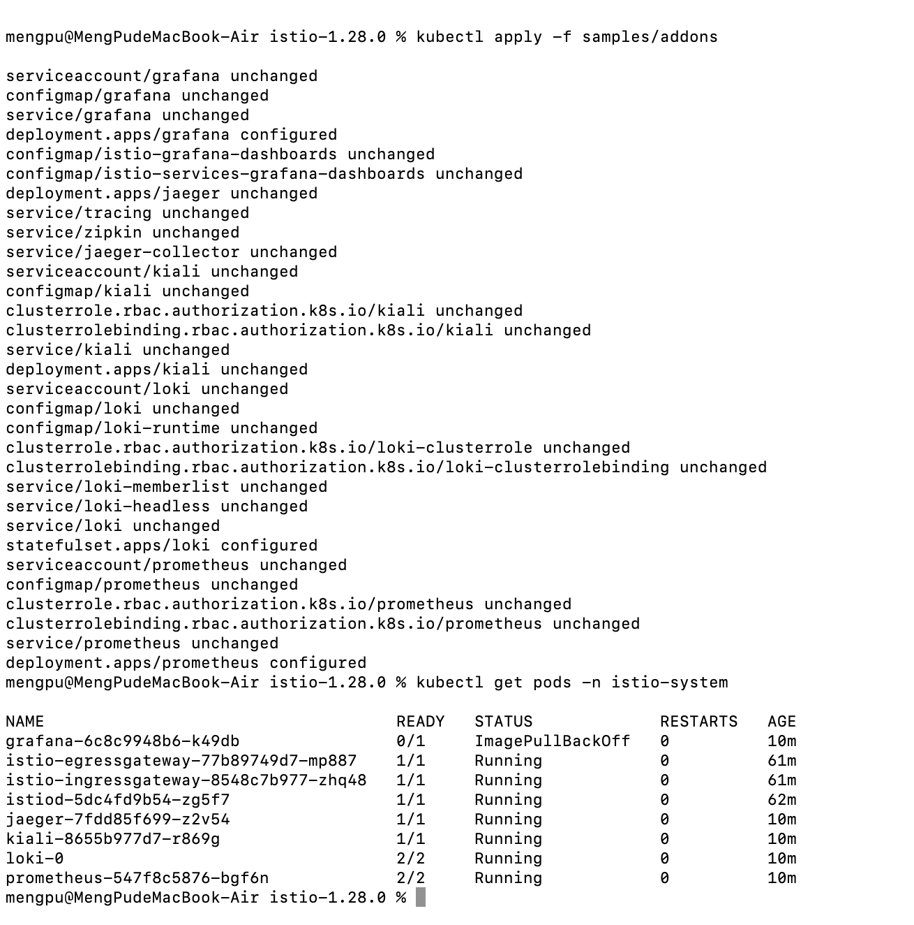
Figure : Deploying Istio Addons including Kiali, Grafana, and Prometheus.
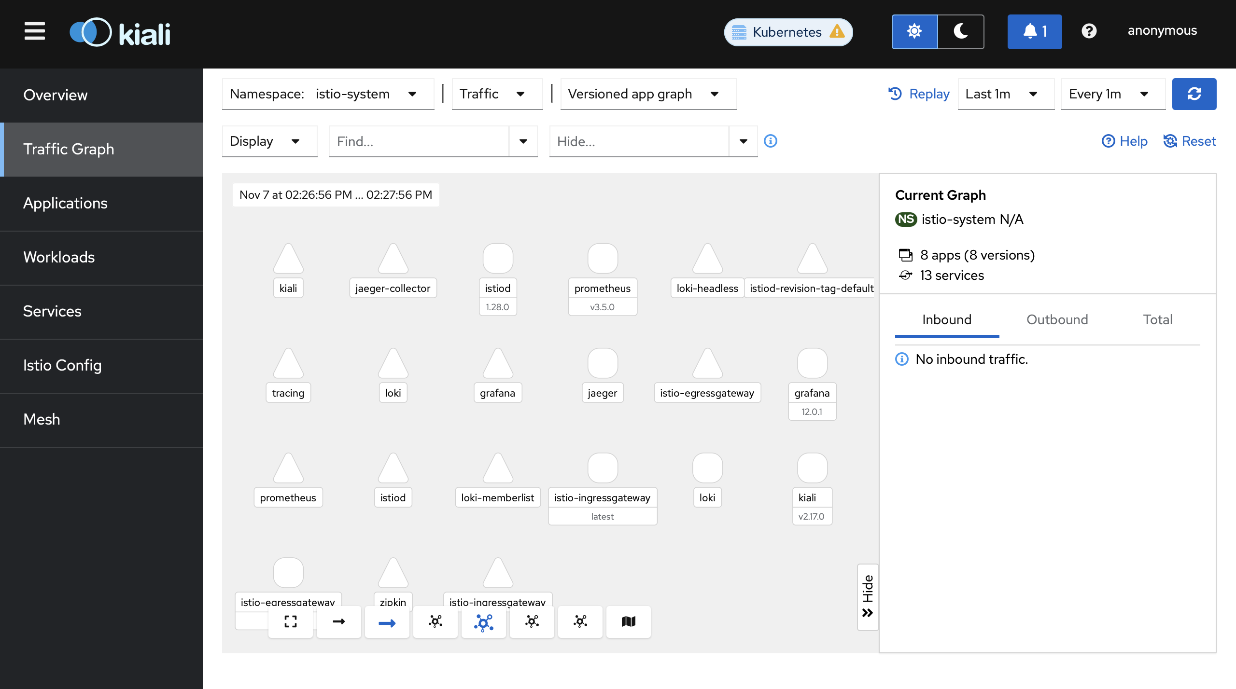
Figure : Kiali dashboard showing system namespace topology.

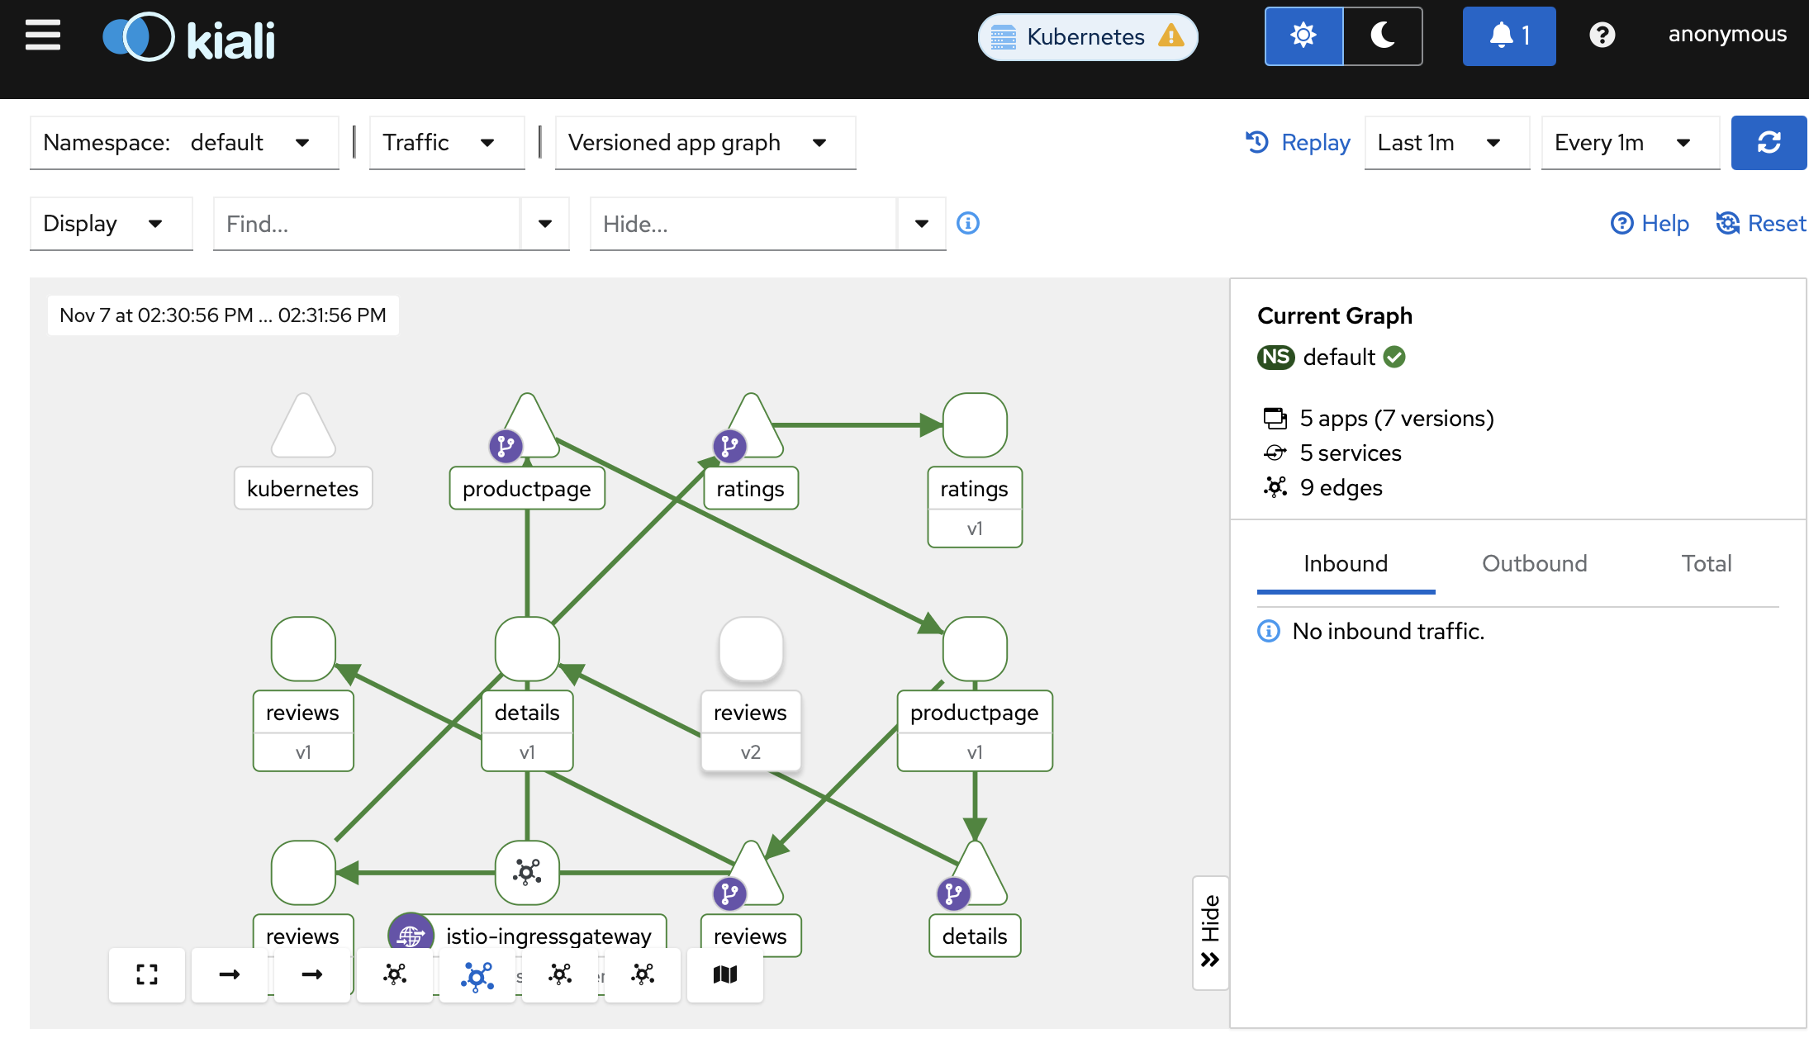
Figure : Kiali traffic graph visualizing Bookinfo microservice interactions.
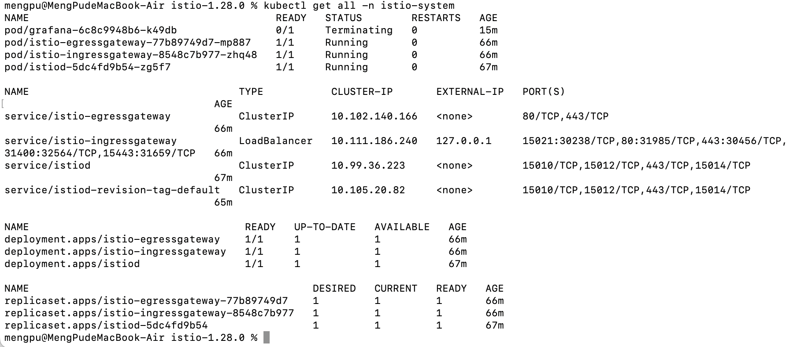
Figure : Cleaning up the Istio environment and removing resources.

